Idea System

The idea of this system is to test and measure the susceptibility (how easy or difficult) to remember the user password within the two systems depend passwords two different ways:

The first system (conventional system) and includes the use of traditional passwords contain (letters and numbers and symbols private) only.

The second system (the new system) and includes the use of the secret unconventional lyrics contain (letters and numbers and special symbols) in addition to the use of a wide range of expressive images (EMOJI PICTUERS) with different connotations.

Conditions and manner of use of the system

The joint followers following terms and steps must be a contribution to the success of this test

The first system (conventional system)

The first stage: the stage of registration in the system (Registration)

. 1-You must be at least the length of a password eight characters, including a mix of Arabic letters (a ... j) and English (large (A ... Z) or small (a ... z)) and numbers (0 ... 9) and special symbols (such as $, #,%, &, \*).

. 2-You should not password selected writing on paper or any other means and sufficiency of trying to remember through all the person's memory

Second stage: the stage of frequent access to the system (Login)

1-This test takes at least four weeks, and must be based subscriber to enter the system repeatedly (to not be less than the period between the entry and the last seven days).

2-Try to remember the password used by memory only, without the use of paper or in any other way is to write the password on it.

. 3-In the case of the inability of the joint from entering the system (because you cannot remember your password) on the first attempt, please try again three times.

. 4-In the case of the inability of the joint from entering the system (due to lack of password remember) after the third attempt, please contact the email address below (......................)

. 5-In the case of a successful bid to enter the system, the joint must determine the level (degree) to remember the password.

. If there are any difficulties in using the system, please contact the email address below - 6 (..................................).

. 7-After the end of the time period prescribed for participation in the test. Please let us know via the following email address (..................................).

The second system (the new system)

The first stage: the stage of registration in the system (Registration):

. You must be at least the length of a password eight characters, including-1

You must include a password to use a different set of images expressive (EMOJI PICTUERS) with different connotations.

. 2-You must not write expressive images (EMOJI PICTUERS) used within the selected password on paper or any other means and sufficiency of trying to remember through person-only memory. The subscriber can Manti writing expressive images used in the password by typing words or configure inter Manti show those pictures to a joint written on paper or by any other means.

. 3-Preferably link expressive images used in the password set of words or sentence indicates representation password on a group of emoticons used. To clarify what has been said at this point, please see the example in the figure below

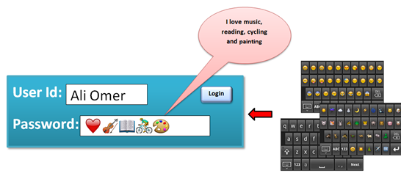:

Second stage: the stage of frequent access to the system (Login)

1-This test takes at least four weeks, and must be based subscriber to enter the system repeatedly (to not be less than the period between the entry and the last seven days).

. 2-Try to remember the password used by memory only, without the use of paper or in any other way is to write the password on it.

. 3-In the case of the inability of the joint from entering the system (because you cannot remember your password) on the first attempt, please try again three times.

4. 4-In the case of the inability of the joint from entering the system (due to lack of password remember) after the third attempt, please contact the email address below (...................... ............).

5-In the case of a successful bid to enter the system, the joint must determine the level (degree) to remember the password.

If there are any difficulties in using the system, please contact the email address below- 6 (..................................).

. 7-After the end of the time period prescribed for participation in the test. Please let us know via the following email address (..................................).